Use Case Specification

DMT/RM01/TMP

|  |  |
| --- | --- |
| Project Code | PRJ_HotelManagement_001 |
| Project Name | Hotel Management |

|  |  |  |
| --- | --- | --- |
| Prepared/Modified by | Role | Date of Preparation |
| Harshita Ahuja | Test Engineer | 20/10/2018 |
| Reviewed by | Role | Date of Review |
|  | SME |  |
| Approved by | Role | Date of Approval |
|  | Test Manager |  |
| Circulation List |  | Version Number of the template: |
| Version Number | 1 |  |

<<Customer>> REVIEW HISTORY

<<Customer comments on the Use case along with the signed off is tracked here>>

|  |  |  |  |  |  |  |
| --- | --- | --- | --- | --- | --- | --- |
| Version | <<Version number>> |  |  |  |  |  |
| Date | <<Date of Review>> |  |  |  |  |  |
| Reviewed by | << Reviewer Name>> |  |  |  |  |  |
| Reviewed UI Specification doc | << Whether UI Specification doc is reviewed >> |  |  |  |  |  |
| All Open Queries/issues closed | << Whether all the open queries and issues resolved>> |  |  |  |  |  |
| Agreement on Assumptions | <<Whether all the assumptions have been agreed upon by the customer>> |  |  |  |  |  |
| Sign Off | <<Signature>> |  |  |  |  |  |

Disclaimer:

The scope of the project ‘<<Project Name>>’ is restricted to the contents of this signed off use case.

TABLE OF CONTENTS

1.Use Case Name: <<Use Case Name>> 4

2.Actor(s) 4

3.Preconditions 4

4.Flow of Events 4

4.1 Basic Flow 4

4.2 Alternative Flows 5

4.2.1 Alternate Flow 1 5

4.3 Sub Flows 6

4.3.1 Sub Flow 1 6

5.Post Conditions 6

6.Special Requirements 7

7.Extension Points 7

<Name of extension point> 7

8.Business Rules 7

9.Diagrams 8

Use Case Diagram 8

Activity Diagram 9

10.Scenarios 10

Success Scenarios 10

Failure Scenarios 10

11.Issues 10

12.UI Specifications 10

13.Inter System Dependencies 11

14.Integration with an already existing System of the <<Customer>> 11

15.Assumptions 11

REVISION HISTORY OF THE WORK PRODUCT…………………………….. .. 12

1. Use Case Name: Hotel Management system

**Use Case ID:** HotelManagement1.0

**Brief Description:** This usecase describes about the adding of the new hotel by the admin.

2. Actor(s)

1. Admin

2. Hotel Management System

1. Preconditions
2. The admin has successfully login into the site <http://ndafile:8081/Spring_Hotel/login.html>.

4. Flow of Events

4.1 Basic Flow

**Name: Sucessfully Adding of New Hotel**

1. Admin enters Hotel city.
2. Admin enters Hotel name.
3. Admin enters Address.
4. Admin enters description.
5. Admin enters average fare per height.
6. Admin enters Phone Number1.
7. Admin enters Phone Number2.
8. Admin selects Rating.
9. Admin enters Email.
10. Admin enters Fax.
11. Admin clicks on Add Hotel button.

* 1. Alternative Flows

Alternate Flow 1: Successful reset of data

1. Admin enters Hotel city.
2. Admin enters Hotel name.
3. Admin enters Address.
4. Admin enters description.
5. Admin enters average fare per height.
6. Admin enters Phone Number1.
7. Admin enters Phone Number2.
8. Admin selects Rating.
9. 4Admin enters Email.
10. Admin enters Fax.
11. Admin clicks on Add Hotel button.

Alternate Flow 2: successful unscheduled cab request

1. Employee selects location.
2. Employee selects PickUp .
3. Employee selects date of travel.
4. Employee selects departure time .
5. Employee verifies the mobile number.
6. Empoyee selects purpose of travel.
7. Employee clicks done button.
8. System displays the message “Request Submitted Successfully” with cab request id.

Alternate Flow 3

Exception Flow 1: unsuccessful unscheduled cab request

1. Employee selects location.
2. Employee selects PickUp .
3. Employee selects date of travel.
4. Employee selects departure time .
5. Employee selects the change box.
6. Employee leaves the mobile number empty.
7. Empoyee selects purpose of travel.
8. Employee clicks done button.
9. System displays the error message “Request Not Submitted” with enter mobile number correctly.

Exception Flow 2 :unsuccessful unscheduled cab request due to wrong date

1. Employee selects location.
2. Employee selects PickUp .
3. Employee selects date of travel as an old date.
4. Employee selects departure time .
5. Employee verifies mobile number.
6. Empoyee selects purpose of travel.
7. Employee clicks done button.
8. System displays the error message “Request Not Submitted” with enter valid date.

Exception Flow 3: Web Server Down

1. Employee selects location.
2. Employee selects PickUp .
3. Employee selects date of travel.
4. Employee selects departure time .
5. Employee selects the change box.
6. The system displays an error message regarding web server unavailability problem

Exception Flow 4: Database Connectivity Error

1. Employee selects location.
2. Employee selects PickUp .
3. Employee selects date of travel.
4. Employee selects departure time .
5. The system displays an error message regarding database connectivity problem.

Exception Flow 5: Network Connectivity Error

1. Employee selects location.
2. Employee selects PickUp .
3. Employee selects date of travel.
4. Employee selects departure time .
5. The system displays an error message regarding network connectivity problem.

Post Conditions

| Flow Name | Post Condition |
| --- | --- |
| Successful Unschedule Cab Request. | System displays the message “Request Submitted Successfully” with cab request id |
| Unsuccessful unscheduled cab request | System displays the error message “Request Not Submitted” with enter mobile number correctly |
| Unsuccessful unscheduled cab request due to wrong date | System displays the error message “Request Not Submitted” with enter valid date |
| Web Server Down | The system should display an error message to the user regarding web server unavailability problem |
| Database Connectivity Error | The system should display an error message to the user regarding the database connectivity problem |
| Network Connectivity Error | The system should display an error message to the user regarding the network connectivity problem |

Special Requirements

Performance

The applicant should receive the mail having the details of cab request id and journey details.

Availability

* 1. Application is up and running 24*7.

Business Rules

| Business Rule Name | Business Rule Description | System action (if BR fails) |
| --- | --- | --- |
| BR01 | Only 4 locations available for select a location drop down list. | Error message is displayed if not selected |
| BR02 | PickUp/Drop down are options available only. | Error message is displayed if not selected |
| BR03 | Project Id is displayed automatically. | Correct Id is dislpayed |
| BR04 | Any one of departure or arrival time is enabled | Error if wrong is enabled. |
| BR05 | Departure time and arrival time has 3 options. | Error message if not selected. |
| BR06 | Contact number to be entered should be of 10 digits. | Error message is displayed an drequest is not submitted. |

Diagrams

Use Case Diagram

* 1. For Successful unscheduled cab request

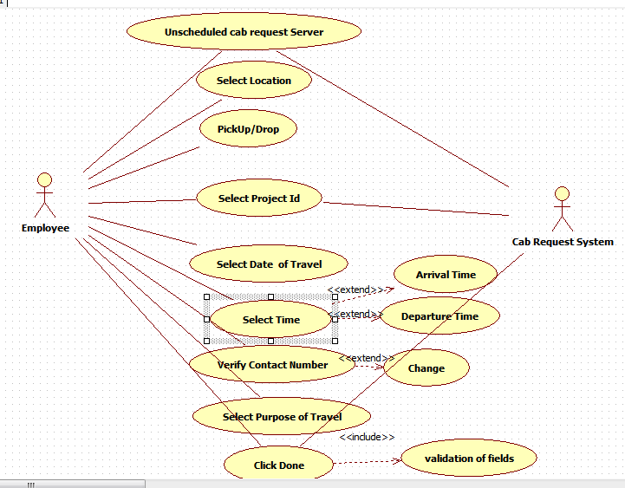

Scenarios

Success Scenarios

* Successful submission of cab request

Failure Scenarios

* Failed submission of cab request due to leaving a field blank.
* Failed submission of cab request due to entering wrong date
* Failed submission of cab request due to entering invalid mobile number.
* Failed submission of cab request due to network error.

Issues

1. What is to be done if web server is down?
2. What is to be done if there is data connectivity error?

UI Specifications

Extension Points

Extension in Alternate FLOW 1:

In step 5, of basic flow if employee checks change field

1. The employee can edit contact number

Assumptions

1.Only company employees can avail this service.

2.The employee has selected appropriate landmark

REVISION HISTORY OF THE WORK PRODUCT

<to be maintained by projects>

|  |  |  |  |  |  |
| --- | --- | --- | --- | --- | --- |
| # | Date | Version # | Section Changed | Details of changes made | Approved By |
| 1 |  |  |  |  |  |
| 2 |  |  |  |  |  |